**Agenda:**

* **Updates**
  + We had to forgo meeting with your moms for final testing, the timing was a bit difficult! That said, we are planning to message them with a link to the application and ask for remote feedback/apps/questions/concerns
  + We’re working on documentation work and preparing for hand-off – as apart of this week’s action items, we’re going to share some text with you to look over, before Friday the 26th @ Midnight, there will be a few things we’ll need your sign off on ASAP – we’ll email as things are done
    - Project description to go on the IS website
    - Logo to go on the IS website
    - Once we finish a statement of completion, we will need you to initial it and look after it
  + Next week, we should meet to prep for our final presentation – this presentation will actually be moreso you speaking, but we want to ensure we work on this together !!
    - 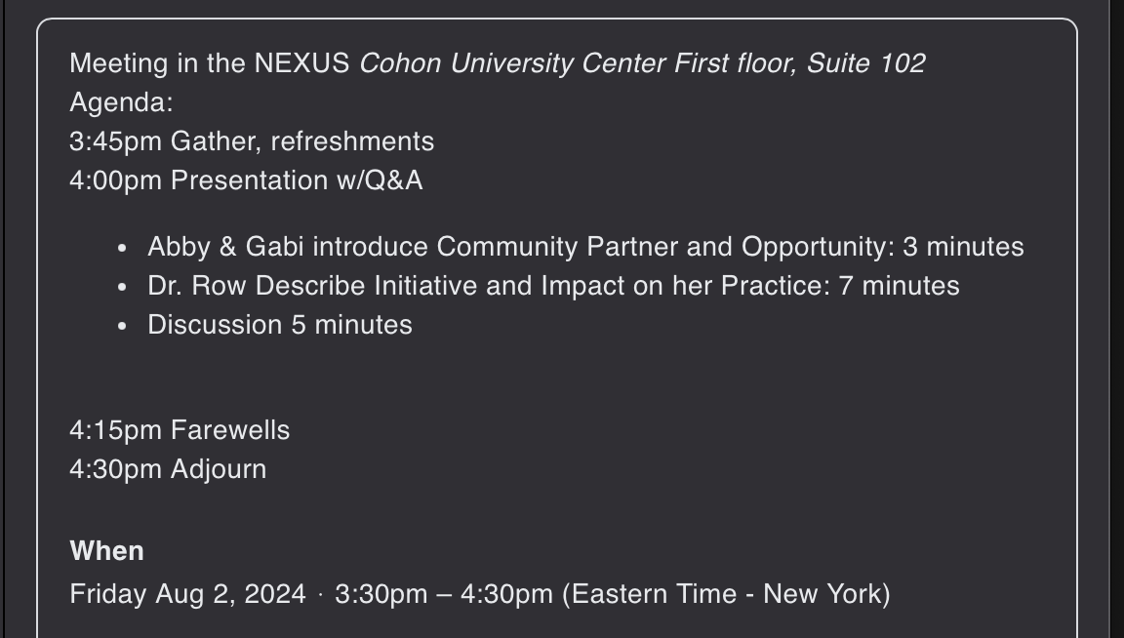
* **Purchases**
  + **Posters & Magnets**
    - Would you like us to handle printing of mini posters/handouts? Do these need to be looked at by UPMC first?
    - Once we get the domain name, I’ll make little square magnets with a QR code for us to use?
    - Magnets – can start with 25 2x2 magnets for $32.40 or 25 3x3 for $39.00 ([Stickeryou](https://www.stickeryou.com/products/fridge-magnets/867))
  + **Domain Name**
    - Do you have an idea of what you’d like it to be hosted as? Please let us know EOD
    - DrRows555 / 555BreathingTechnique / 555BreathingTech / DrRowsBreathing / DrRows555BreathingTech
* **Cost Analysis/3rd Party vendor check-in**
  + We need to decide something this week, especially prior to client hand off. Do you have an idea/a final decision on how you’d like to host this project/carry it forward after the next coming weeks? If the answer is Abby, then that contractual work should be completed this Friday, or before Aug 2nd if we can get that approved by Prof. Poepping
* **Our final Steps**
  + Less distraction, filmed inside, can put this in the app now, and leave space for a new one to be filmed – Include in rec. for next team
  + Calming imagery/waves with your voice over head
* **Actions Items 4 Dr.Row**
  + Record self doing the 555
  + Sign off on items as they come
* **Next week’s meeting modality & time: July 29th @ 12PM, MODALITY !!**

**Notes:**

* **Aug2do: mockups of the magnets and postcards, get prices**
* She’s gonna decide to go w/ Abby, then potentially working w/ 373 team (likely)
  + Future team could work on permanent solution
  + They can do transferal of applications to applications
  + Can continue to do updates to content on the application